NAME : SURIYA T ROLL NO : 241501228

EXP.NO: 4

Create a web form that accepts a user's name and age. Write a Servlet to process the form data and display it back on the browser.

AIM

To create a simple web application that includes a form to accept a user's name and age, and then use a Servlet to process the submitted data. The Servlet will retrieve the form data, process it, and display the values back on the browser.

ALGORITHM
- Input:
• The user fills out a web form with their name and age and submits it.
2. Form Handling and Servlet Processing:
1. Create the Web Form:
- Create an HTML form with two input fields: one for the user's name and one for the user's age.
- Add a submit button to the form.
- Set the form's action attribute to the URL of the Servlet and the method to POST (or GET).
2. Create the Servlet Class:
- Write a Servlet that processes the form data submitted by the user.
- The Servlet will override the doPost() (or doGet() depending on the form method) to handle form submissions.
- The Servlet will retrieve the name and age parameters from the request object using request.getParameter("name") and request.getParameter("age").
3.Process the Data in the Servlet:
- Extract the name and age values submitted from the form.
- Validate the input (e.g., check if the age is a valid number).
- Prepare a response that will display the user's name and age back on the browser.
4. Send Response to the Browser:
- The Servlet will send a response to the browser containing a message like: ♣ "Hello, [name]! You are [age] years old."
- The response will be displayed to the user in the browser.
5. Deploy the Servlet:
- Compile the Servlet and deploy it to a Servlet container (like Apache Tomcat).
- Ensure the web.xml file or Servlet annotations are used to map the Servlet to the URL defined in the form's action attribute.
6. Test the Application:
- Open the web browser, fill in the form with the name and age, and submit it.
- The Servlet will process the data and display the message back to the user in the browser.

CODE

Servlet.java
package com.example;

import java.io.IOException;
import java.io.PrintWriter;

import javax.servlet.ServletException;
import javax.servlet.annotation.WebServlet;
import javax.servlet.http.HttpServlet;
import javax.servlet.http.HttpServletRequest;
import javax.servlet.http.HttpServletResponse;

@WebServlet("/UserServlet")

public class Servlet extends HttpServlet {

protected void doPost(HttpServletRequest request, HttpServletResponse response)
throws ServletException, IOException {

response.setContentType("text/html");

PrintWriter out = response.getWriter();

String name = request.getParameter("name");
String ageStr = request.getParameter("age");

int age;

try {
age = Integer.parseInt(ageStr);
} catch (NumberFormatException e) {
out.println("<h3>Invalid age entered!</h3>");
return;
}

out.println("<html><body>");
out.println("<h2>Form Data Received</h2>");
out.println("<p>Hello, " + name + "!</p>");
out.println("<p>You are " + age + " years old.</p>");
out.println("</body></html>");
}
}

form.html
<!DOCTYPE html>
<html>
<head>
<title>User Form</title>
</head>
<body>

<h2>User Information Form</h2>

<form action="UserServlet" method="post">

Name:
<input type="text" name="name" required>
<br><br>

Age:
<input type="number" name="age" required>
<br><br>

<input type="submit" value="Submit">

</form>

</body>
</html>
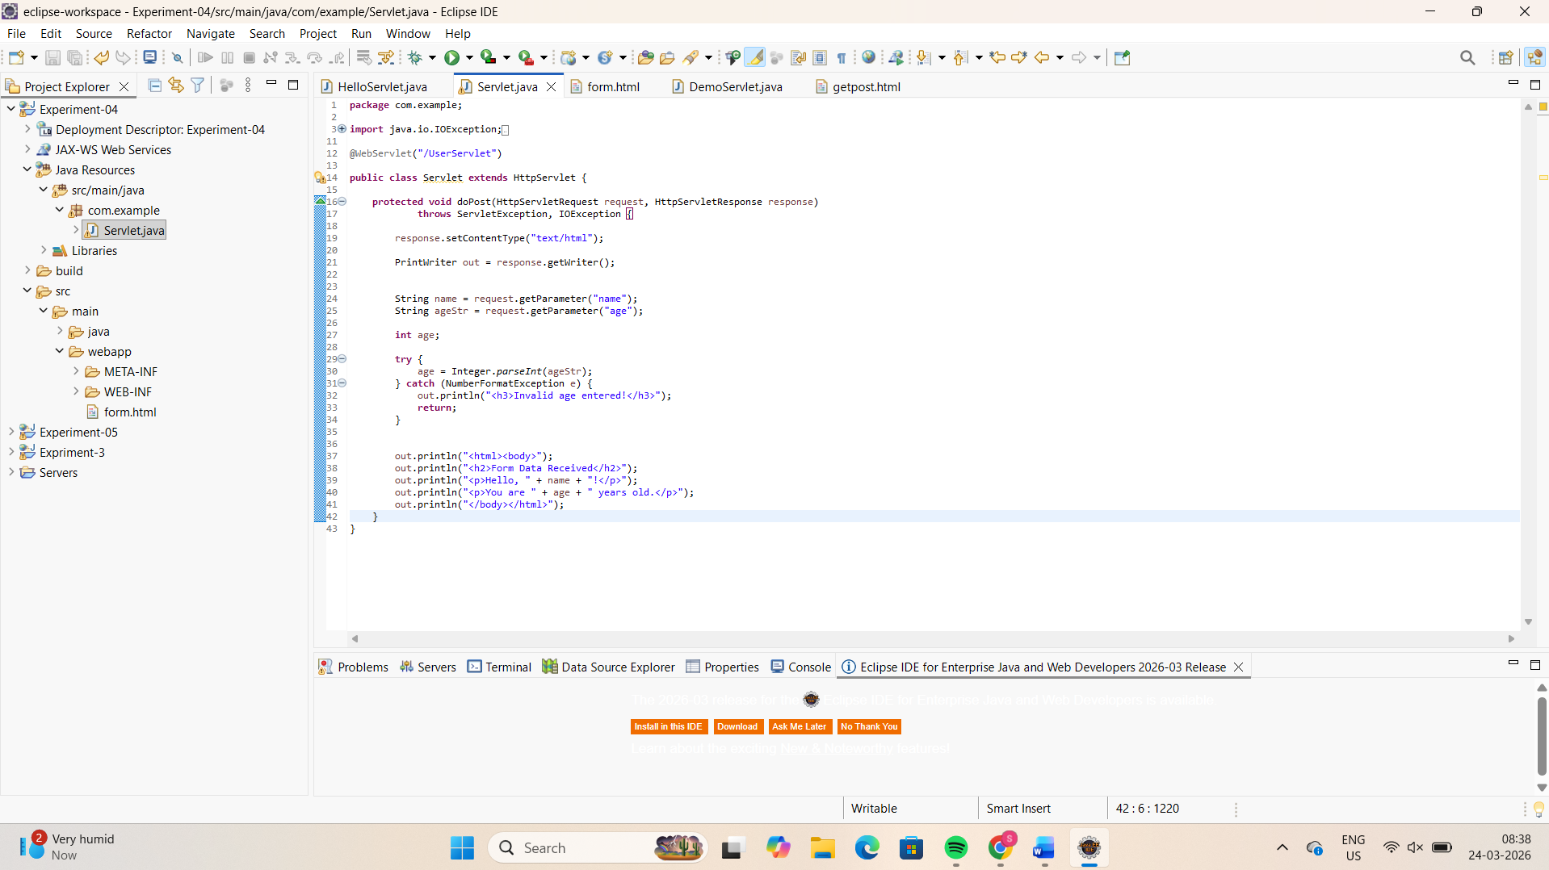
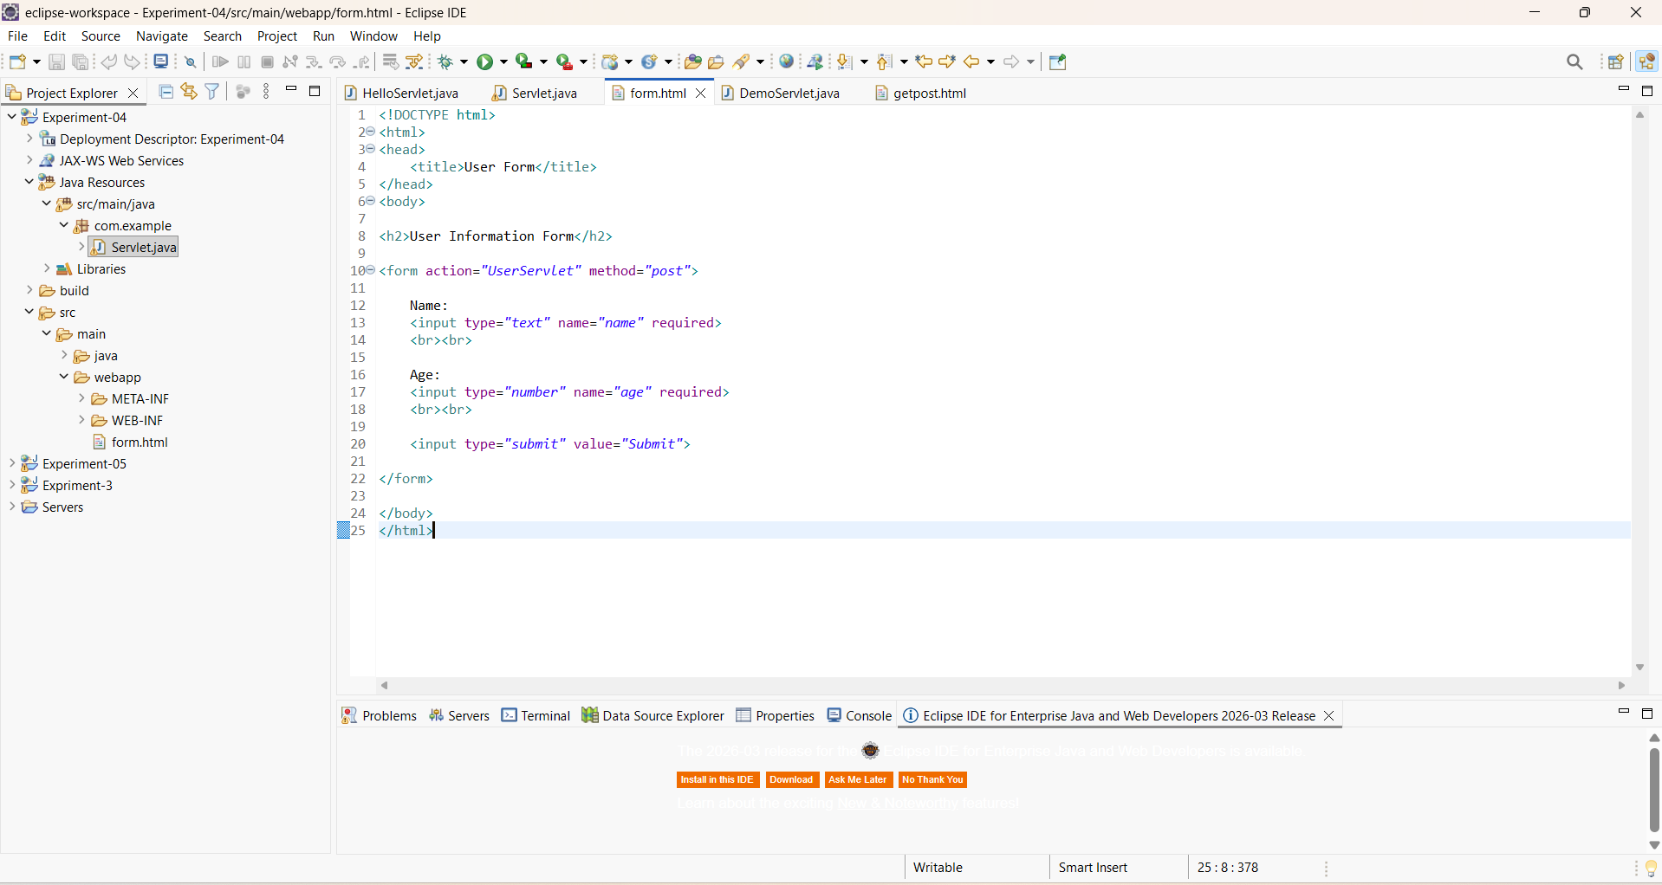

OUTPUT
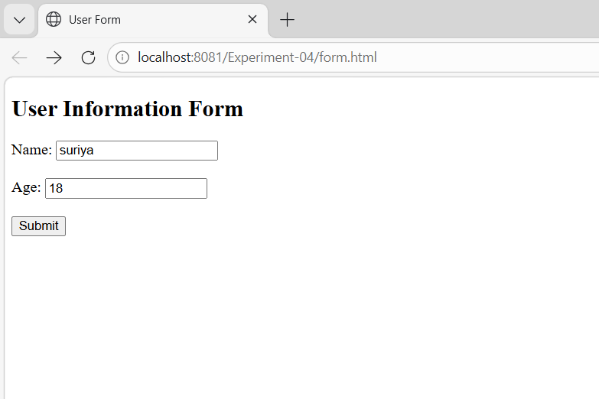
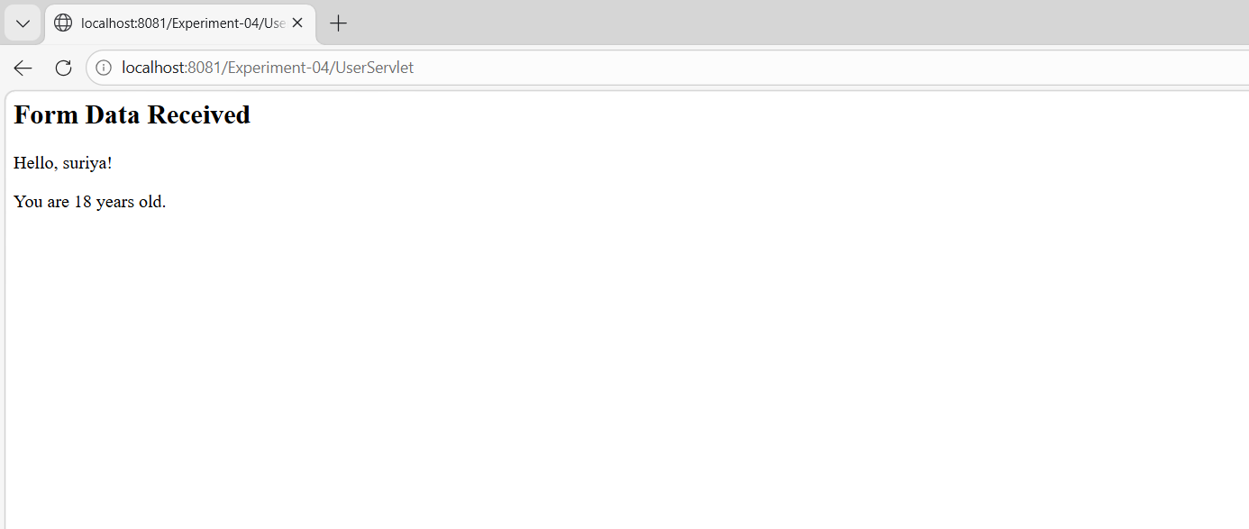

RESULT
A Servlet is created to process the HTML form data and display it back on the browser.

